**Project Name: Handling User Authentication**

**Developer Name:** Kapil Davey

**GitHub Link:** [**https://github.com/kapildavey/Phase-3.git**](https://github.com/kapildavey/Phase-3.git)

**Output:**

* **Create an authentication class that has all the methods related to user authentication:**

**● Create a JUnit test class to create unit tests for the authentication class:**

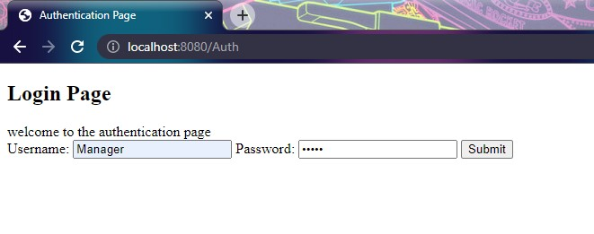

**● Run the test class directly as a JUnit and check if all the tests pass:**

